**Write program for PDA that accepts the L={anbn}**

**Source Code:**

states = ['q0','q1','q2']

pda = []

string = input("Enter the string ")

lstring = list(string)

count = 0

pda.append('z0')

state = states[1]

print("The sequence of states")

for i in range(len(string)):

if(pda[count]=='z0' and state == states[1] and lstring[i]=='a'):

pda.append('a')

count+=1

elif(pda[count]=='z0' and state == states[1] and lstring[i]=='b'):

pda.append('b')

count+=1

elif(pda[count]=='a' and state == states[1] and lstring[i]=='a'):

pda.append('a')

count+=1

elif(pda[count]=='a' and state == states[1] and lstring[i]=='b'):

pda.pop(count)

count-=1

elif(pda[count]=='b' and state == states[1] and lstring[i]=='a'):

pda.pop(count)

count-=1

elif(pda[count]=='b' and state == states[1] and lstring[i]=='b'):

pda.append('b')

count+=1

elif(pda[count]=='z0' and state == states[1] and lstring[i]==' '):

pda.append('b')

count+=1

state = states[2]

print(state)

if(state==states[2]):

print("The string has been accepted")

else:

print("The string has not been accepted")

**Output:**

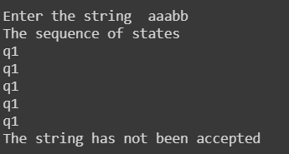

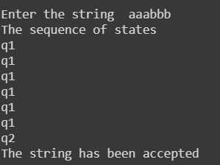

**Conclusion:**

Thus, program for PDA that accepts the L={anbn} can be written as above